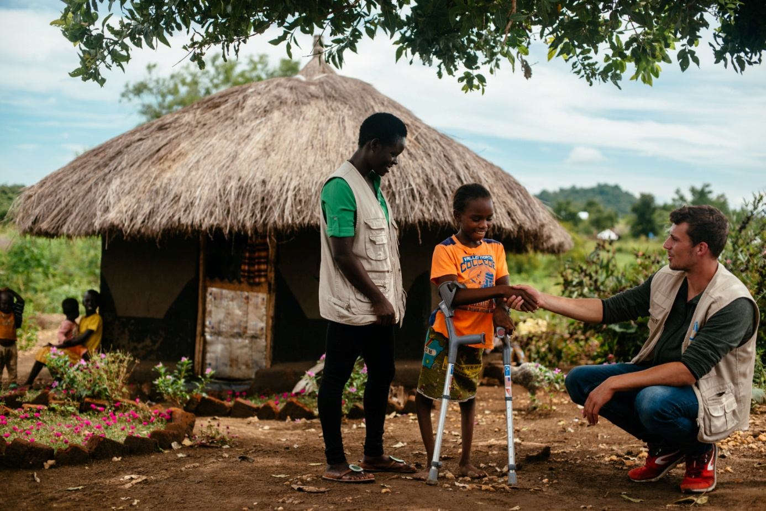

Practical guide
From project

Guidance brief: How to start, maintain or end a mechanism for coordinating disability inclusion in humanitarian action?

Division: Resilience & Inclusion
Date: 062024

PG ı FP ı n°




Authors
Laurène Colin, Ulrike Last

Contributors
Sien Andries, Youri Francx, Riem Khan

A Humanity & Inclusion publication
Resilience & Inclusion

Editing & Layout
Stéphanie DEYGAS ‒ Innovation, Impact & Information Division

Rights & Licenses
This work is available under the Creative Commons Attribution-NonCommercial-NoDerivatives 4.0 International license (CC BY-NC-ND 4.0). Under the Creative Commons-NonCommercial-NoDerivatives license, you are free to copy, distribute, and transmit this work, for noncommercial purposes only, under the following conditions:

Attribution-Please cite the work as follows:
Laurène Colin, Ulrike Last. Guidance brief: How to start, maintain or end a mechanism for coordinating disability inclusion in humanitarian action?. Lyon: Humanity & Inclusion, 06 2024. License: Creative Commons Attribution-NonCommercial-NoDerivatives 4.0 International (CC BY-NC-ND 4.0).
Noncommercial-You may not use this work for commercial purposes.
No Derivative Works-You may not alter, transform, or build upon this work.

Contents

Purpose 4
Whether and when to start? 5
How to start? 5
Who to engage as members and coordinators? 6
Where to position within the Cluster or Sector Coordination System? 6
How to promote meaningful participation and empowerment of persons with disabilities? 8
Ensuring Accountability 9
Leadership and meaningful participation of organizations of persons with disabilities 9
Resourcing Disability Inclusion Working Groups 9
How to maintain working groups? 10
Typical activities of DIWGs to address gaps 10
When and how to close DIWGs 13

Purpose
This guidance brief has been developed based on lessons learned from existing disability inclusion (and age) working groups, and in particular, those that were interviewed during Mapping of Mechanisms for Coordination of Disability Inclusion and the Comparative Case Study Collection. For more information on this type of structures, see the UNICEF introduction to Disability Working Groups.
Disability (and age) Inclusion Working Groups have been set up in at least 16 countries, where large scale refugee or humanitarian responses with activated cluster system take place. They have found collective answers to enhance the visibility of disability in the inter-agency data collection process and methods, empowered OPDs to meaningful participate in response planning and/or contributed to advancing capacities of humanitarian programmers on disability inclusion.
The following pages describe what are possible starting points, how to maintain a functioning working group, and how to close it.
Actionable recommendations are aligned with good practice documented and what is recommended in the IASC Guidelines on Inclusion of Persons with Disabilities in humanitarian action, thereafter referred to as IASC Guidelines on Disability Inclusion.

Whether and when to start?
Working groups or task forces on disability inclusion at country/ response level can be setup to address agreed gaps at inter-agency level in relation to disability-inclusive coordination, the humanitarian program cycle, and the collective humanitarian response to a crisis. Those gaps need to be important enough to require a working group and cannot be addressed by one agency alone. Those gaps and challenges can relate to, for instance:
- Operational coordination: Humanitarian agencies have an unmet need to coordinate and exchange about gaps, approaches, tools and standards around access and meaningful participation of persons with disabilities, in order to not duplicate action;
- Disability inclusive information management: Insufficient information on risks, specific and basic needs, capacities and participation of persons with disabilities across the humanitarian sectors due to insufficient data collection & analysis capacities, tools and/or practices;
- Humanitarian response planning and needs assessment processes and/or outcome documents insufficiently address the risks, participation and resilience of persons with disabilities;
- More barriers than enablers exist for persons with disabilities to participate in humanitarian program cycle related consultation, monitoring, programming and safeguarding approaches, including AAP or PSEA, and decision making processes;
- OPDs, Persons with disabilities are not meaningfully engaged in advocacy & their needs and risks insufficiently visible in advocacy and resource mobilization; and/or
- Technical and learning resources aren’t available to support humanitarian leadership, sector and inter-sectorial coordination, humanitarian information systems and programmers to have appropriate and inclusive data for programming and/or resource mobilization to address capacity gaps for ensuring equal humanitarian and protection outcomes for persons with and without disabilities.

How to start?

Ensure a minimum of four, yet committed agencies that agree on commonly observed, existing gaps that negatively affect their organizations and the collective humanitarian response to reach, monitor the risks and access of and/or engage persons with disabilities meaningful and effectively.
Have regular meetings with a clear agenda to discuss and agree on the common gaps and move forward. Depending on the urgency the frequency can be decided. If the founding members agree to do a systematic assessment of gaps and opportunities, there exists an in-depth.

Who to engage as members and coordinators?

A mix of local and/or international representative Civil Society Organizations (CSOs), disability-inclusion focused and/or mainstream agencies from NGO, OPD and UN side by side who share a common interest around addressing gaps around disability inclusion.
Among those interested it’s good to have two to three key agencies with technical and operational capacities to facilitate the process of forming and/or maintaining a group/ task force.
If the gap is the lack of a coherent disability-inclusive responses within and across clusters, it can be effective to invite disability-inclusion focal persons per cluster/ organization. If such focal points do not exist, it is possible to initiate or encourage the appointment of those by cluster lead agencies.
In such instances, where the gap is around disability-inclusive data collection, engagement of data producing agencies at inter-agency response level, can be fruitful.
If there are only humanitarian NGOs engaged, it is advisable to identify relevant UN agencies and reach out to OPDs, if they exist, successively and vice versa. Good practice documentation has found that engaging UN agencies is especially important when gaps in HNRPs/ RRPs and more broadly the humanitarian program cycle or humanitarian leadership are to be addressed. (see also the section 9 and 10 of the IASC Guidelines for roles and responsibilities, and here in particular cluster and humanitarian leadership sections).
If members of the working groups, including OPDs, are interested but are less familiar with the humanitarian response and roles and responsibilities of stakeholders, capacity strengthening on the humanitarian program cycle and structure is advisable. Likewise, if international actors are not familiar with local realities and context, capacity strengthening initiatives are suitable measures to address those gaps.

Where to position within the Cluster or Sector Coordination System?

Once the core common gaps and interests are agreed, discuss with the interested future members of a working group/ task force, where best to be integrated or hosted within the existing humanitarian coordination system.
For the group to be effective and efficient it’s important to discuss strategically, where it should be placed within the humanitarian coordination system and within the geographic realities of a given crisis. As per the IASC Guidelines, and looking at the evidence from the mapping report, comparative case study and an individual case study, there is no one place to position it. Rather, in relation to the identified gaps identified some positionings are promising better traction than others.
As there is no clear responsibility or place identified in the humanitarian system, positioning also depends on openness of the given structure to accommodate.
Below you will find a selection of gaps that correspond to being hosted in a specific structure:
- Inter-cluster/ sector coordination system: Is the relevant position for a disability inclusion working group or a task force associated with a Gender and Inclusion Road Map team if the potential gaps and entry points that were identified can best be addressed through positioning it at the inter cluster/ sector level.
- Relevant Gaps:
- Inter-agency information and management systems insufficiently include disability in the multi-sector needs assessments;
- There are no disability inclusion focal points per cluster and/or cross-cutting thematic (AAP, Localization, Gender, PSEA, or similar) and they lack coordination between clusters, work in silos;
- Agencies from multiple clusters have capacities to and an interest to coordinate actions and learning around disability inclusion and meaningful participation of persons with disabilities in the response;
- Gaps in Humanitarian Needs and Response Planning processes, that span across multiple sectors.
- Protection Cluster: Is the relevant structure if the identified gaps and protection risks experienced by persons with disabilities require a coordinated response by and with other protection actors, and the protection cluster through its centrality of protection is well positioned to raise concerns of marginalized groups at heightened risk to the humanitarian country team/ leadership.
- Potential gaps that respond to a positioning at the protection cluster and/or its AoRs:
- Protection risk and needs assessments show a heightened exposure of persons with disabilities to violence, abuse, discrimination and barriers in accessing their basic needs and being safe;
- Lack of disability-inclusive or specific referral/ case management system;
- Gaps in the protection section of the Humanitarian Needs and Response Planning processes, that span across multiple sectors;
- Violence, abuse and atrocities against persons with disabilities is known but not visible in the protection risks and monitoring efforts, protection monitoring updates, protection strategy or action planning at inter-agency level, and advocacy launched by the HCT;
- There is no regular discussion on persons with disabilities’ situation in the protection cluster, and no focal person with the protection cluster identified; and/or
- High number of requests raised by protection cluster coordination team and/or cluster/ sector WG members for training and/or learning sessions and/or tool adaptation/ review on disability inclusion.
- Next steps, if any of the above gaps are reflected in the analysis:
- Initiating agencies and/or Protection Cluster Coordinator presenting the gaps and discuss the suitable positioning;
- Once agreed, engage them in the governance and TOR discussions.
- WASH, CCCM, health, education, food security, MHPSS and/or other sector or cluster working groups:
- As for protection, when gaps and requests for information management, prioritization, response planning and/or capacity strengthening relate to a particular sector, it is advised setup a task force and/or a temporary working group within a given singular cluster.

How to promote meaningful participation and empowerment of persons with disabilities?
- The mapping of existing mechanisms showed that only in two out of sixteen OPDs were co-leading such coordination spaces;
- Therefore, specific attention should be placed on promoting and providing the space for OPDs to engage as members and co-chairs of such working groups/ task forces;
- Resourcing of reasonable accommodation, participation and capacity strengthening of OPDs on the humanitarian program cycle, when required, should be featured in.
- See recommended resources on enhancing meaningful participation of OPDs and persons with disabilities in the Tipsheet on meaningful participation in this toolkit.

Ensuring Accountability
- After you have identified the right positioning at cluster/ sector or inter-cluster level:
- Arrange a meeting with the specific cluster (Protection, WASH, etc.), OCHA, ICCT, Gender and Inclusion Road Map team and/or the Humanitarian Country team to present the gaps, discuss and agree the suitable positioning.
- Once agreed, engage the associated structure in the governance and TOR discussions.
- See tip sheet for drawing up the TOR.
- Based on the gaps discuss with the members of the Working Group/ Task Force the actions to take collectively and what resources are required to address the gaps.
- See the template for typical action plans.

Leadership and meaningful participation of organizations of persons with disabilities
- From the start, as much as possible, OPDs representing the affected population with disabilities, can take a key role in initiating and/or co-facilitating the process of forming a working group/ task force.
- If they lack capacities on humanitarian programming and related processes, and/or barriers exist to their meaningful participation, discuss joined actions that can strengthen their capacities to meaningfully engage and/or take on leadership.
- See resource section in the Tipsheet on meaningful participation of the toolkit.

Resourcing Disability Inclusion Working Groups
- Mapping and case studies have shown that resourcing for the coordinator or co-leads’ time, required for running the working group, corelated with effective and efficient working processes and outcomes.
- See the executive summary of the Comparative Case Study on mechanism to support disability inclusive coordination report for more information
- Hence, it is recommended to fundraise for the functioning of such working groups. In some instances, the functioning of such working groups/ task forces was included in the Humanitarian Response plan as a common service.
- Likewise, resources for activities, such as consultations, contribution to existing data collections, training and/or consultations, accessibility and/or reasonable accommodation for engaging persons with disabilities is required.

How to maintain working groups?
- Facilitate regular reviews of results achieved, reflection and/or assessments of gaps and enablers that will help to understand the level of integration of disability and meaningful participation of persons with disabilities in the HPC and the response;
- In some working groups, peer learning sessions and community of practices around disability inclusive project management, adaptation of delivery modalities and joined training initiatives, can be key to advance operational capacities on disability-inclusive programming. Tools that can be used:
- DRG Learning Modules on introducing disability inclusive project cycle management
- E-Learning Modules on inclusive project cycle management and Cash Modalities
- Tools promoting the quality use of the Washington group set of questions
- HNRP process related guidance and report on good practices on how to make response planning more disability inclusive
- To establish the working group as a space to co-create and/or peer review existing policies, assessment tools, sector specific standards and/or guidance tools of shared interest to members;

Typical activities of DIWGs to address gaps
- Operational coordination: Humanitarian agencies have a need to coordinate and exchange about gaps, approaches, tools and standards around access and meaningful participation of persons with disabilities, in order to not duplicate action;
- Undertake and maintain a mapping of OPDs and/or disability specific service providers for referral purposes on addressing specific
- Disability inclusive information management: insufficient information on risks, specific and basic needs, capacities and participation of persons with disabilities across the humanitarian sectors due to insufficient data collection & analysis capacities, tools and/or practices;
- Invite and/or engage with the Information Management Working Group which often exists at inter-cluster/ sector level engaged in the multi-sector needs assessments;
- Briefing, technical support and/or learning sessions on integrating disability into existing data collection exercise;
- Support analysis of disaggregated data if requested, co-create with data actors and/or prepare regular briefs extracting data on the most important risks, capacities and unmet needs of persons with disabilities per sector or across the sectors to ease the update of information on their situation by other humanitarian actors and present them to specific sectors or the HCT in preparation of the HNRP;
- Provide and/or channel technical expertise and/or facilitate consultation with OPDs for analysis and prioritization of inter-sectorial needs assessments findings;
- Humanitarian response planning and needs assessment processes and/or outcome documents insufficiently address the risks, participation and resilience of persons with disabilities;
- Undertake peer reviews with representatives of interested clusters/ sector on the status of disability inclusiveness of the HNRPs and discuss possible avenues to amend those;
- Co-create with data actors and/or prepare regular briefs extracting data on the most important risks, capacities and unmet needs of persons with disabilities per sector or across the sectors to ease the update of information on their situation by other humanitarian actors and present them to specific sectors or the HCT in preparation of the HNRP;
- Jointly input on the HNRP processes by sector and on inter-sectorial aspects;
- More barriers than enablers exist for persons with disabilities to participate in humanitarian program cycle related consultation, monitoring (including AAP, PSEA) and decision making processes;
- Fundraise for reasonable accommodation to reduce barriers
- Undertake awareness raising and learning session on barrier-free communication
- Representative and technically versed DIWG members engage in the vetting process, guidance development, call for proposals document review, and training of Country Based Pool Fund (CBPF) mechanisms and the steering committee as disability inclusion experts
- Development of inclusion criteria
- Support the training of interested applicants on disability inclusive assessments
- Persons with disabilities are not meaningfully engaged in advocacy & their needs and risks insufficient visible in advocacy and resource mobilization around reducing the impact of a particular crisis; and/or
- Undertake awareness raising and learning session on barrier-free communication towards humanitarian leadership on risks faced by persons with disabilities;
- Facilitate and/or prepare key messages on persons with disabilities, ideally to be shared by OPDs;
- Promote and empower OPDs, representing affected population, to engage during donor events and/or conferences on major crisis;
- Fundraise for reasonable accommodation during such events;
- Monitor resources allocation around addressing the risks of persons with disabilities
- Technical and learning resources aren’t available to support humanitarian leadership, sector and inter-sectorial coordination, humanitarian information systems and programmers to have appropriate data for programming and/or resource mobilization to address capacity gaps for ensuring equal humanitarian and protection outcomes for persons with and without disabilities.
- Based on requests and identified gaps promote existing e-learning, hybrid sessions and/or undertake localized and contextualized capacity strengthening activities, such as training or learning sessions
- Apart from addressing the gaps there is relevant work to be done on communicating the work and share information through the response platforms
- It is recommended to support a people-centred approach by connecting as much as possible with the work of the gender in humanitarian action working groups, Accountability to Affected Population working groups to provide coherent feedback on HNRPs, humanitarian country strategies and/or multi-sector needs assessment processes
- Resources for each of the typical activities are included in the guidance for self-assessments of entry points and gaps on disability inclusive coordination, a too contained in this toolkit.

When and how to close DIWGs
As the rationale for the existence of such working groups is to address certain gaps in information and to ensure operational and effective coordination around disability inclusion, once those gaps are addressed, disability is integrated across the response planning, data collection and information sharing, advocacy and enablers are in place to ensure meaningful participation of persons with disabilities, they should be closed.
The entry point and engagement matrix, part of this toolkit can be used to assess the inclusiveness of the humanitarian coordination system helping the discussion among the DI WG members.

Guidance brief: How to start, maintain or end a mechanism for coordinating disability inclusion in humanitarian action?

This document presents the learning by HI teams in the field and at HQ level around setting up, maintaining and/or closing a mechanisms to coordinate disability inclusion in humanitarian actions. The guide reflects on mechanisms that take the form of disability (and age) inclusion working groups. They are commonly attached to the Protection Cluster or the

Humanity & Inclusion
138 avenue des Frères Lumière
69371 Lyon CEDEX 08
France
publications@hi.org

This working group can have different names in different country: assessment and analysis working group

