Funding Cuts and the Humanitarian Reset:

What They Mean for Persons with Disabilities
Disability Reference Group (DRG) | October 2026

Between July and August 2026, the Disability Reference Group (DRG) assessed how the cuts in humanitarian funding since 2025 and the Humanitarian Reset are affecting disability inclusive humanitarian action. This work included a survey of DRG members, focus group discussions with organisations of persons with disabilities (OPDs), and key informant interviews with UN and NGO staff.

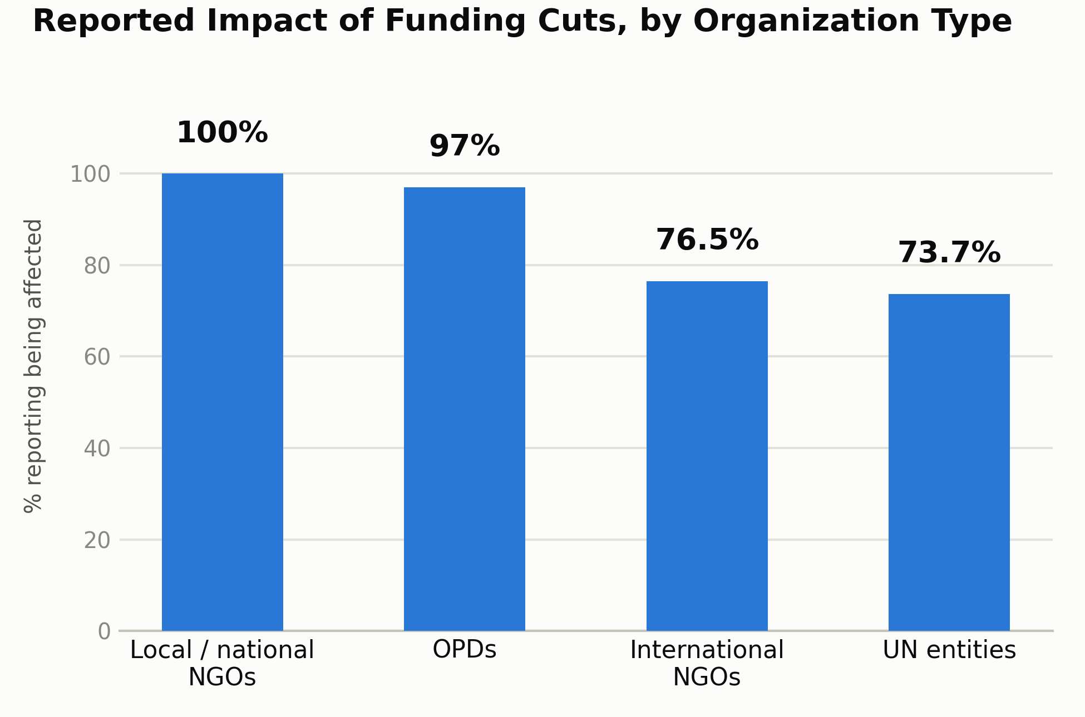
Key findings

Not targeted but disproportionately impacted. 88% of respondents say their disability-inclusion work has been affected, which is up from 75% in June 2025. While disability inclusion doesn’t seem to be specifically targeted by funding cuts, it is among the first things dropped when broader programmes contract, as it was rarely ring-fenced.
OPDs absorbing the deepest impact. 97% of OPDs and 100% of local/national NGOs report their disability inclusion work being affected, against roughly 75% of UN entities and INGOs. These cuts further exacerbate the years of under-resourcing that OPDs were already experiencing.
Multiple dimensions of impact. The most commonly reported impact on persons with disabilities is more limited access to humanitarian assistance (88%), followed by increased risk of violence, exploitation and abuse (75%).
Humanitarian Reset decisions carry their own risks, separate from funding cuts. Life-saving criteria risk undermining the importance of rehabilitation and assistive technology, which enable access to assistance; while simplified data collection risks making persons with disabilities invisible again.
Where it is protected, it holds. Earmarked budget lines, dedicated expertise, leadership commitment and accountability mechanisms are the four factors that keep disability inclusion intact even under cuts.

What this means against the Humanitarian Reset's priorities
The Humanitarian Reset aims for faster, fairer, more accountable action, delivered closer to the people affected by crisis. Disability inclusion safeguards are how ‘fairer’ and ‘accountable’ can get tested in practice.

DEFINE focusing response on greatest need
Hyper-prioritization around lifesaving criteria is pushing disability-specific support, such as rehabilitation, assistive technology, and accessible communication toward the margins.

DEVOLVE shifting power, leadership and resources closer to communities
OPDs describe being included in funding consortia for compliance rather than genuine partnership and receiving a smaller share of funding. Local actors are expected to take on more at the exact moment their funding is shrinking.

DELIVER making response faster and leaner
Streamlining is affecting disability inclusion first: 36% of respondents report actual or planned cuts to disability-inclusion staff, often merged into broader portfolios without added time or budget. In-country working groups, a key entry point for OPDs, which often carry no dedicated funding, are among the structures most exposed as coordination mechanisms are simplified.

“Simplifying processes can help us respond to reduced capacities, but we need to make sure that ‘simpler’ doesn’t mean losing the targeted actions that support disability inclusion.” UN entity, global level

DEFEND protecting humanitarian principles, with principled, non-discriminatory access at its core
88% of respondents expect that persons with disabilities will have more limited access to humanitarian assistance, and 75% expect an increased risk of violence, exploitation and abuse.

What this means for decision makers
For humanitarian leadership
Simplification without explicit recognition of persons with disabilities risks a narrowing of humanitarian assistance, excluding those who are consistently among those facing the highest severity of need.
- Build a routine disability-inclusion checkpoint into decision-making at country and global level.
- Recognize disability inclusion measures as lifesaving where they are what enables access to assistance.
- Maintain disability-disaggregated data as a standard in needs assessment and monitoring.
- Sustain country-level disability inclusion coordination capacity and ensure real OPD seats in coordination mechanisms.
For donors
Disability inclusion currently receives 0.1% of allocable ODA against an estimated 38+ million people with disabilities in need. When funding for it is not protected, it disappears first, not by deliberate decision, but because it was never ring-fenced.
- Protect dedicated, flexible, multi-year funding for disability inclusion so it is not the first line cut when budgets tighten.
- Fund enablers, such as assistive technology, accessible communications, infrastructure and transport, as core programme costs, not add-ons.
- Invest in funding streams that OPDs can access directly, with eligibility and reporting proportionate to grant size; and require fair shares to OPDs where funding flows through consortia.

The DRG's commitment. We will continue to track the impact of funding cuts and policy shifts; consolidate evidence on what works to protect disability inclusion; and speak with one voice to donors and humanitarian leadership.

Full findings and recommendations can be found in in the companion report, available at the DRG website here.
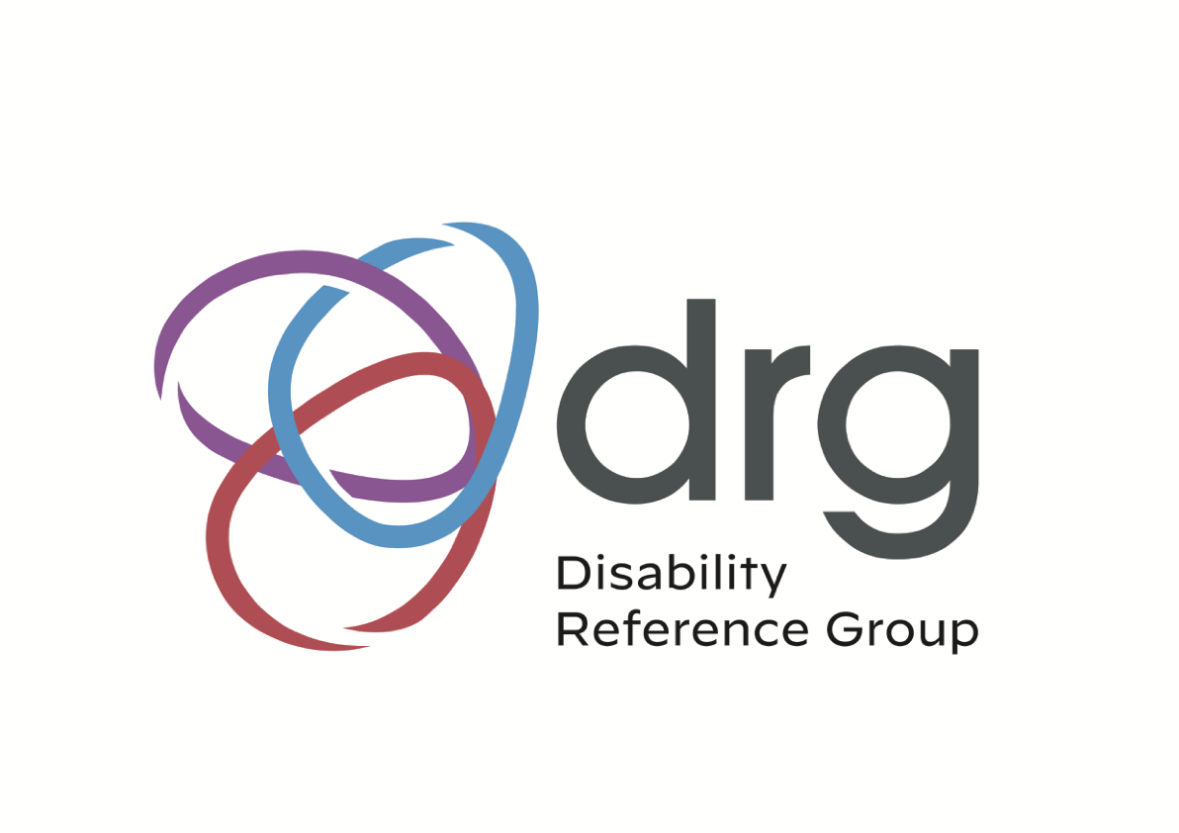
The Disability Reference Group (DRG) facilitates cooperation among organizations of persons with disabilities (OPDs), NGOs and UN entities to promote disability-inclusive humanitarian response. It is co-chaired by the International Disability Alliance (IDA), Humanity & Inclusion (HI) and UNICEF.

